Aggregate Supply

Topic 1: Short-run and long-run analyses

Difficulty Level 1
- The aggregate supply curve shows the relationship between the aggregate output supplied and
  - aggregate price level
  - aggregate money supply
  - aggregate unemployment rate
  - aggregate imports
  - aggregate real interest rate
- According to the short-run aggregate supply curve, as price level rises in the economy
  - worker productivity rises
  - the unemployment rate decreases
  - aggregate supply increases
  - the quantity of aggregate supply increases
  - the quantity of aggregate supply decreases

Difficulty Level 2
- Which of the following statements is true about the “short-run” period in macroeconomic analysis?
  - It is equal to one fiscal year
  - It is equal to the time needed to end a recession
  - It is a period in which wages and input prices are fully flexible
  - It is a period in which wages and input prices are fixed
  - It is a period in which price level does not change

- In the long-run, the price of labor is flexible. What is the resulting effect on the aggregate supply curve?
  - It becomes horizontal
  - It becomes vertical
  - It becomes negatively sloped
  - It becomes positively sloped
  - It does not change
- Since wages and input prices are fixed, or “sticky,” in the short-run, how will producers likely respond to a increase in price level in the economy?
  - Producers will increase production of goods and services
  - Producers will decrease production of goods and services
  - Producers will not change the quantity of goods and services produced
  - Producers will lay off workers
  - Producers will reduce purchases of physical capital

Difficulty Level 3
- What is the effect of an increase in price level on the quanity of aggregate output supplied in the short-run and in the long-run?
Short-run output Long-run output
  - Increase Increase
  - Increase Remains the same
  - Decrease Remains the same
  - Increase Decrease
  - Remains the same Remains the same

Topic 2: Sticky versus flexible wages and prices

Difficulty Level 1
- Employers are reluctant to increase nominal wages during an economic expansion and workers are reluctant to accept wage cuts to nominal wages during an economic downturn. Which term best describes wages in this labor market?
  - Flexible
  - Real
  - Potential
  - Sticky
  - Variable

Difficulty Level 2
- Which of the following choices best describes wages in the short-run and in the long-run?
Short-run Long-run
  - Fixed Fixed
  - Fixed Flexible
  - Flexible Flexible
  - High Low
  - Low High

Topic 3: Determinants of aggregate supply

Difficulty Level 2
- Which of the following changes will cause an increase in short-run aggregate supply?
  - an increase in nominal wages
  - an decrease in personal income taxes
  - a decrease in labor productivity
  - a decrease in commodity prices
  - an increase in the aggregate money supply
- An increase in nominal wages will most likely result in
  - an increase in aggregage demand.
  - a decrease in aggregate demand.
  - a decrease in short-run aggregate supply.
  - an increase in short-run aggregate supply.
  - a decrease in long-run aggregate supply.
Use the graph below to answer the following questions.
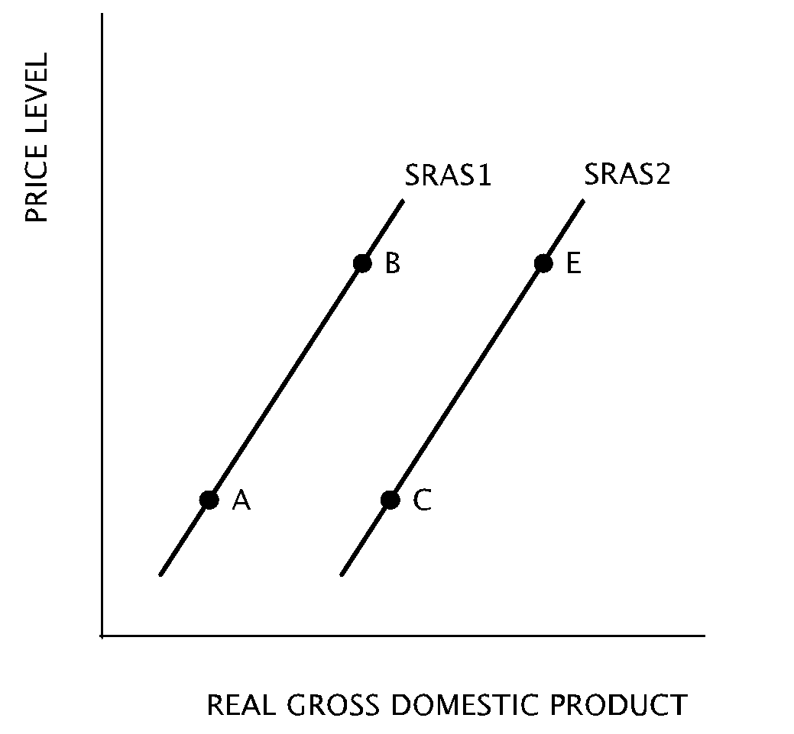
- A movement from Point A on SRAS1 to Point C on SRAS2 is likely to occur when there is an increase in
  - the cost of productive resources
  - productivity
  - price level
  - the federal budget deficit
  - the money supply
- A tax increase of 75 cents per gallon of gasoline would likely cause a movement
  - from Point A to Point B
  - from Point B to Point A
  - from Point B to Point E
  - from Point E to Point B
  - from Point C to Point B
- Which movement on the graph would best represent an economy in which a new law is passed mandating a reduction in automobile pollution?
  - from Point A to Point B
  - from Point B to Point A
  - from Point B to Point E
  - from Point C to Point B
  - from Point C to Point A
- Which of the following changes will likely cause a movement from Point B on SRAS1 to Point E on SRAS2?
  - The shutdown of factories and movement of production of goods abroad
  - A decrease in the money supply
  - An across-the-board reduction in wages in manufacturing jobs
  - An increase in the effective minimum wage
  - The passage of a new law requiring improvements in worker safety
- A movement from Point A on SRAS1 to Point B on SRAS2 is likely to occur when there is an increase in
  - the cost of productive resources
  - productivity
  - price level
  - imports
  - interest rates
Aggregate Supply
1 | A | 6 | B | 11 | A
2 | D | 7 | D | 12 | D
3 | D | 8 | B | 13 | E
4 | B | 9 | D | 14 | C
5 | A | 10 | C | 15 | C

